

**November Candidate Forum Announcement**

**BCA Newsletter**

**June Election Issue 2014**

**2014 November Election Forum**

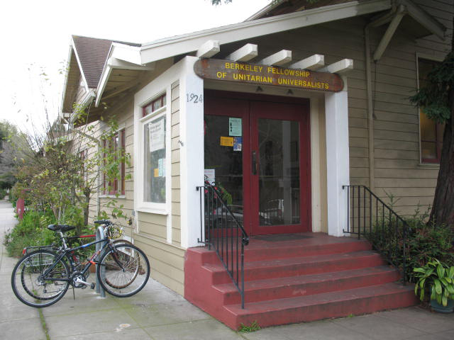

**Sunday, September 21, 3:30-6:00pm**

**Fellowship Hall, 1924 Cedar Street at Bonita**

Presented by Berkeley Citizen Action & Berkeley Tenants Union, along with the Social Justice Committee of the Berkeley Fellowship of Unitarian Universalists.

Help us select the best candidates! Meet the candidates for the November 2014 Election. Local Candidates and representatives for local measures will speak. Some races and ballot measures will be contentious. All are welcome to attend. Hear their ideas, ask questions!

*Note: After the speeches, BTU and BCA members will remain to vote on their respective endorsements for progressive candidates and measures.*

If you intend to vote for the BCA Endorsement, you must be a paid up BCA member. Join now. Former members may pay their membership fee at the door.

We need your help to continue BCA’s longstanding tradition of amplifying the voice of Berkeley’s progressive citizens. Members enjoy these benefits:

* Member newsletters, Facebook and Webpage
* Forums on elections and issues important to residents
* Opportunity to help select the candidates and measures that best reflect Berkeley’s values. Some have likened the BCA endorsement to the “Good Housekeeping Seal of Approval” for Berkeley progressives. Whether voting by mail or at the polls on election day, voters all over Berkeley refer to BCA endorsements to guide their choices.

**Join or renew your membership.**

**Yes! I’ll help BCA maintain a committed, progressive presence in Berkeley!**

Each mailing costs about $300. Please send us your working email address. Please make an extra donation to cover costs!

Name: Annual Membership $35

Email: Low-Income Membership $10

Mailing Address One Time Contribution $_________

City ________________________________________ ZIP Monthly sustaining pledge:

Phone: $25 ______ $10 _______ $________

I would like to participate in the following:

____ Steering Committee ____ Organize Education forums ____ Maintain Web Page and Newsletter ____ Outreach

Other: _______________________________________________________________________________________________

Send to your membership form & money to BCA, P.O. Box 9932, Berkeley, CA 94709 • Call: (510) 982-6528

Web: [www.BerkeleyCitizensAction.org](http://www.BerkeleyCitizensAction.org) • Email: [BerkeleyCitizenAction@gmail.com](mailto:BerkeleyCitizenAction@gmail.com) • Like us on Facebook